Practical No. 1
NAME NASRULLAH / ROLL NO 44
Aim: Write a program in order to explain the concept of class and objects. 1.1) To create simple Car class and its object
Input:
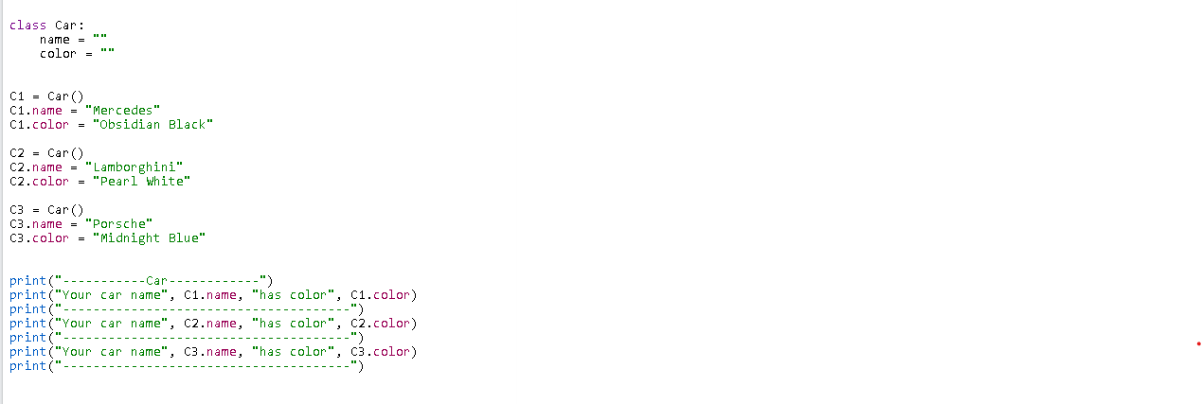
Output:
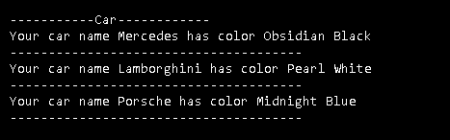

1.2) Making a class for circle:
Input:
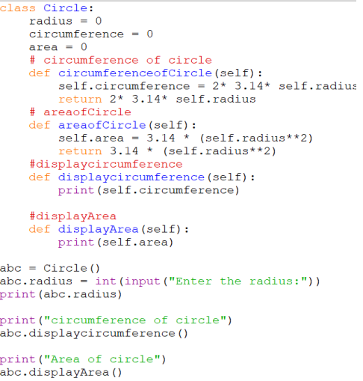

Output:

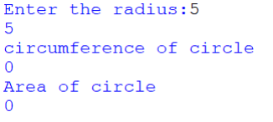

1.3) Example of Constructor:
Input:
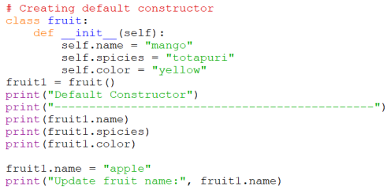
Output:
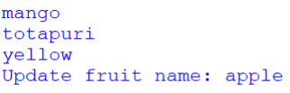
1.4) Destructor: Delete of the object
Input:
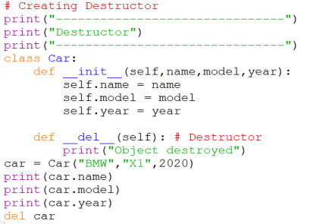
Output:
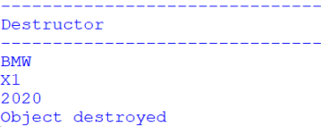

1.5) Employee Biodata Collection:
Input:
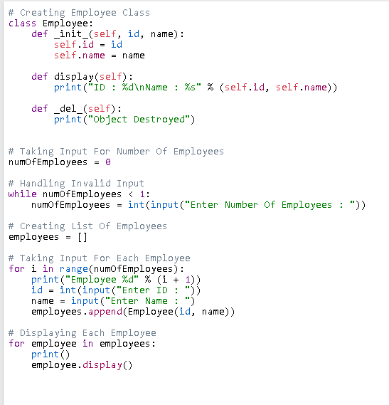
Output:

